Evan Tilley

elt2141

Competitor Research – Tunnel Website

One resource that provides information about the Columbia tunnels is WikiCU.

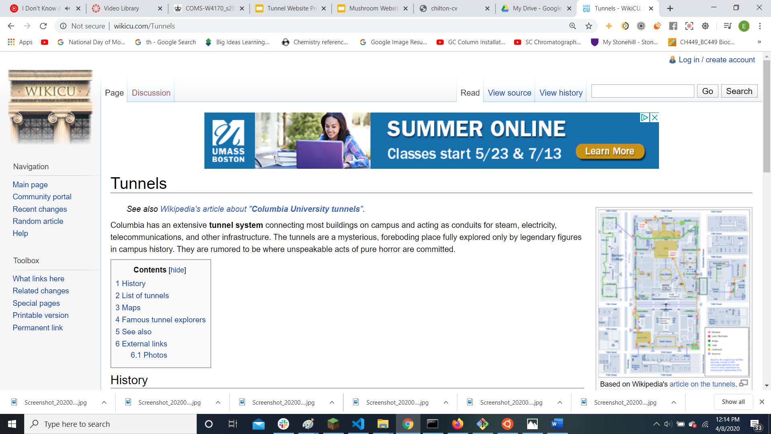

I like that the WikiCU page includes a map of the tunnels and some basic history concerning the tunnels. However, much of the information on the site is outdated and not applicable for current Columbia students. In addition, there are few actual photographs of the tunnels on the website, which prevents students from fully learning about the tunnels. WikiCU also simply has one basic and un-interactive map, which could be made more detailed and support user interaction.